**DAILY ONLINE ACTIVITIES SUMMARY**

|  |  |  |  |  |  |  |  |  |
| --- | --- | --- | --- | --- | --- | --- | --- | --- |
| **Date:** | **23rd june,2020** | | | | | **Name:** | **Prathusha K A** | |
| **Sem & Sec** | **4th sem &b section** | | | | | **USN:** | **4AL18CS061** | |
| **Online Test Summary** | | | | | | | | |
| **Subject** | | **_** | | | | | | |
| **Max. Marks** | | **_** | | **Score** | | | **_** | |
| **Certification Course Summary** | | | | | | | | |
| **Course** | **Webinar on IOT** | | | | | | | |
| **Certificate Provider** | | | **AIET** | | **Duration** | | | **1.5 hrs** |
| **Coding Challenges** | | | | | | | | |
| **Problem statement: Write a C program to Sort a stack using a temporary stack.** | | | | | | | | |
| **Status: done** | | | | | | | | |
| **Uploaded the report in Github** | | | | | **yes** | | | |
| **If yes Repository name** | | | | | **https://github.com/prathu47/lockdown-coding** | | | |
| **Uploaded the report in slack** | | | | | **yes** | | | |

Certification Course Details: (Attach the snapshot and briefly write the report for the same)

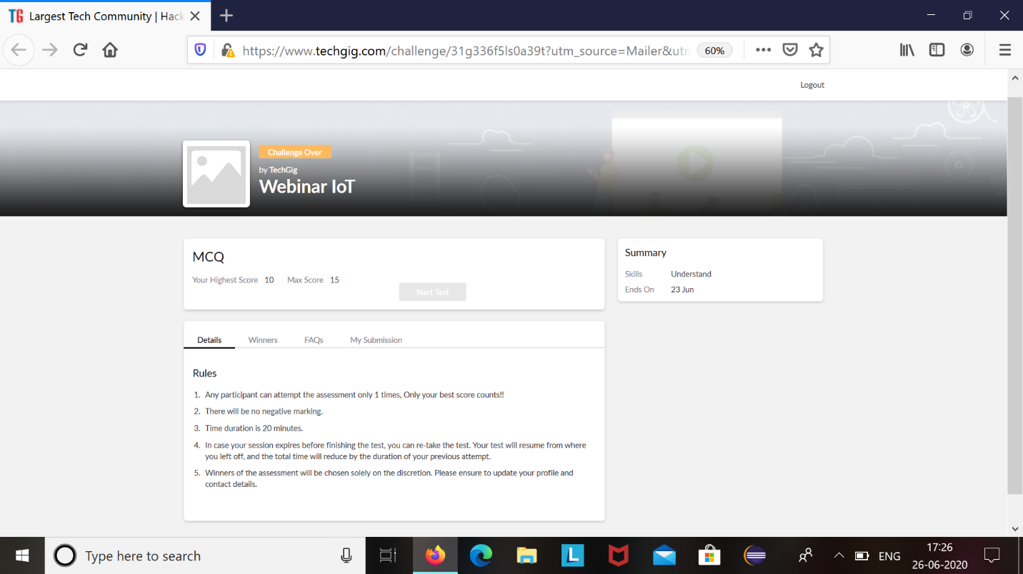

Webinar IOT was conducted by AIET at 10 AM and ended at 11:30 AM . The session was about internet of things and the test was conducted based on it at 4:00 PM. The above was the result sheet from TechGig.

Coding Challenges Details: (Attach the snapshot and briefly write the report for the same)

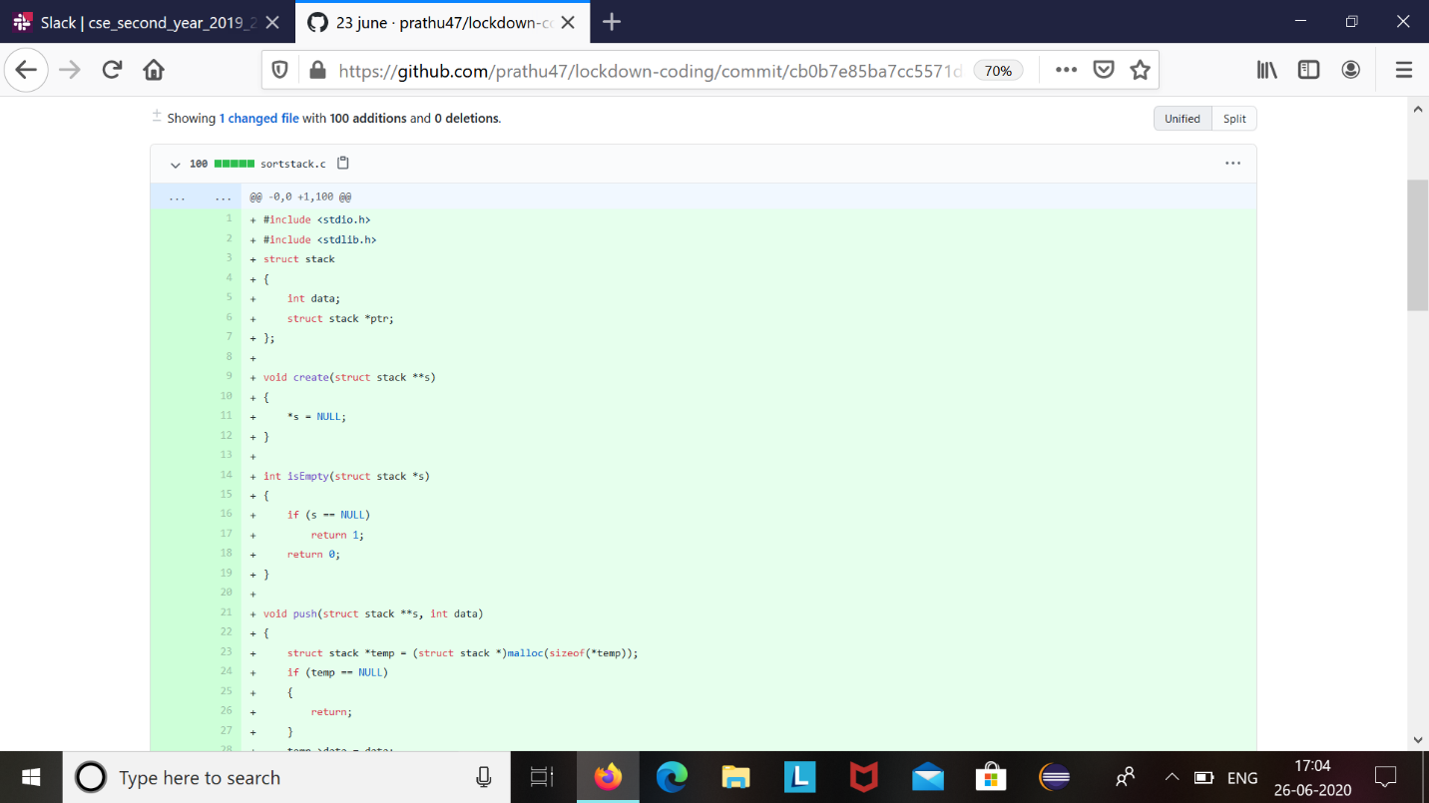

The question we had received today was :

Write a C Program to Sort a stack using a temporary stack.

Code:The above snapshot is the code which I have uploaded in my github repository.